Research for Ui Screens
Account Sign Up and Login Screens
https://mobbin.com/explore/mobile/screens/signup
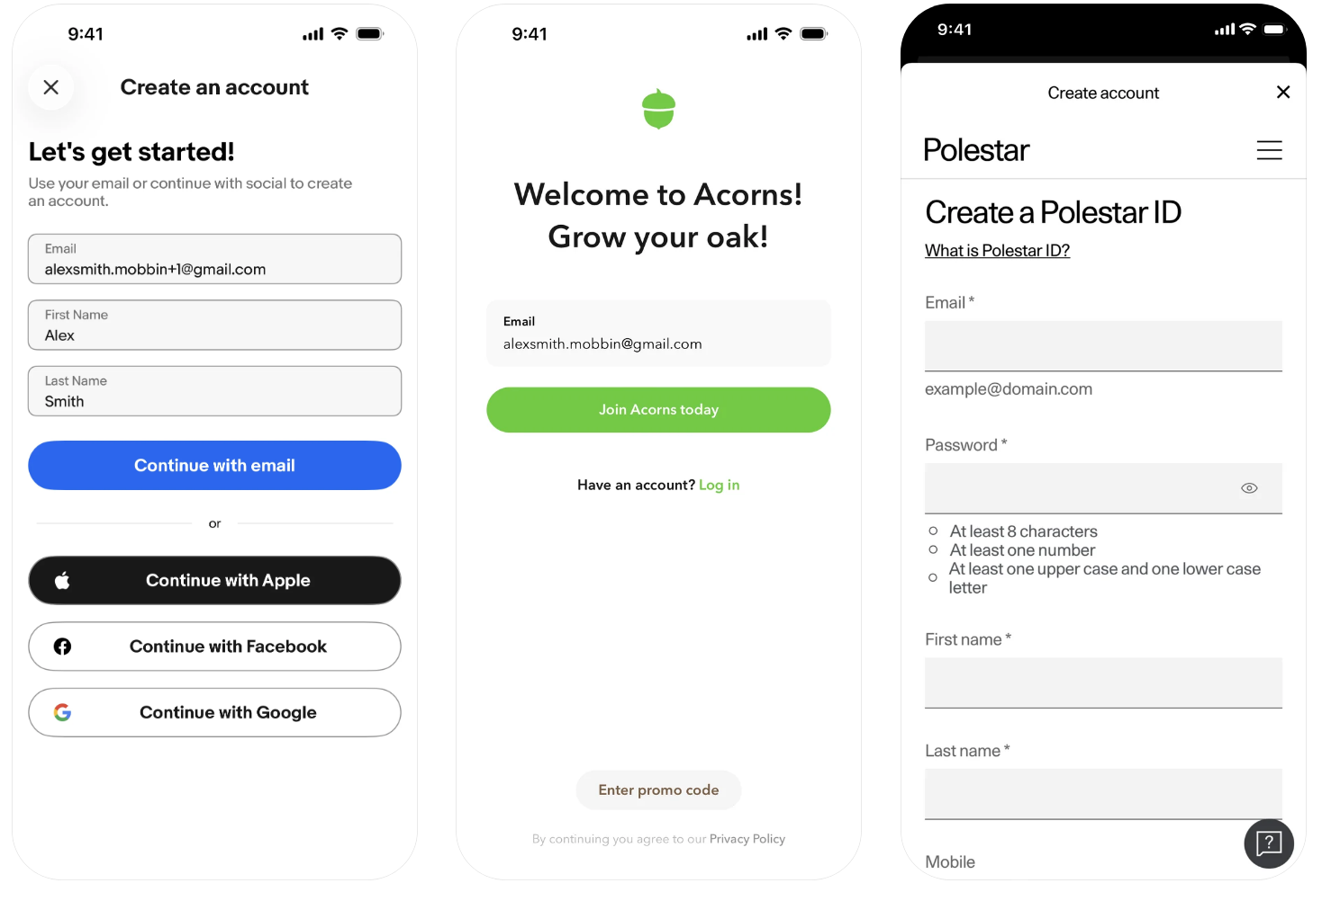
Borrowed Ideas of the top – down layout of the Polestar and eBay apps

Duolingo Dashboard Screens
https://dribbble.com/shots/6641265-Duolingo-Dashboard
https://www.autonomous.ai/ourblog/finch-self-care-app-review-full-breakdown

Mock Up Ui’s

Accounts
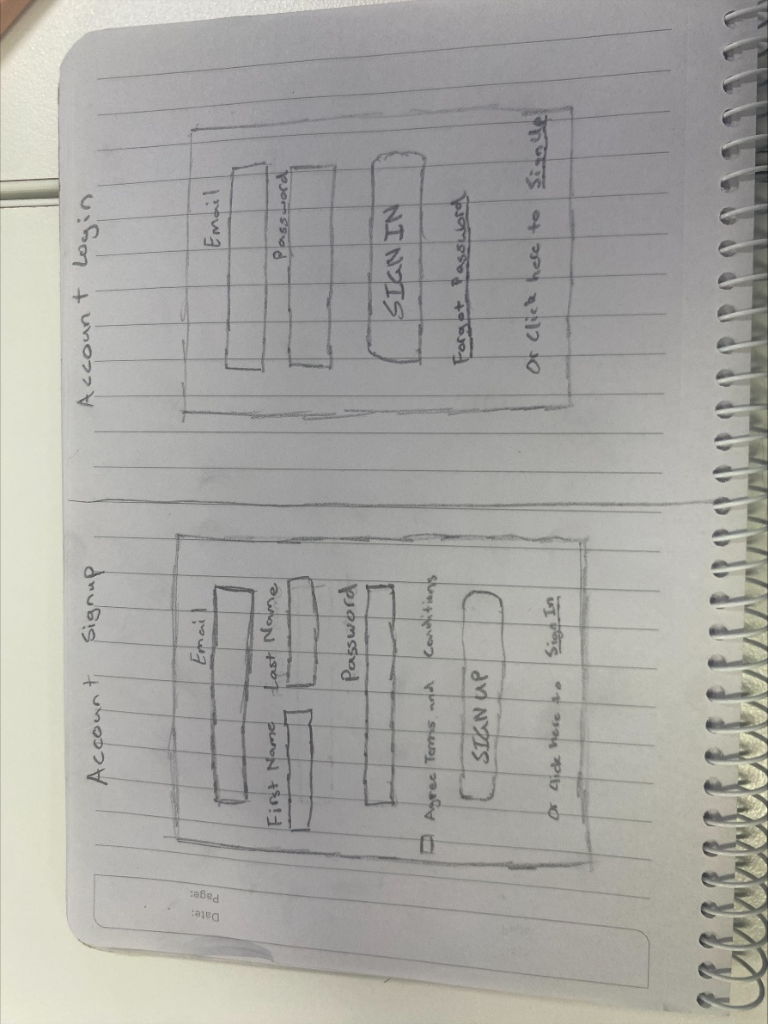

Dashboard and Profile
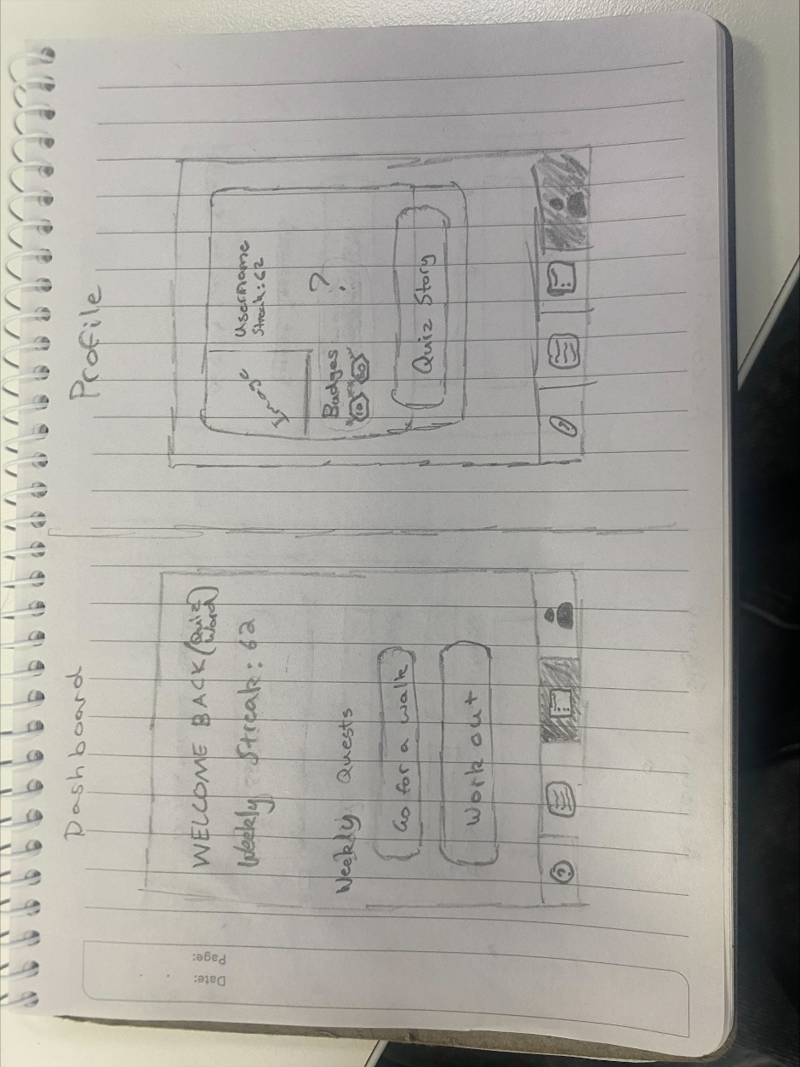

Quiz’s
